**Javascript Basic**

*-Compiled by: Angshuman Gupta*

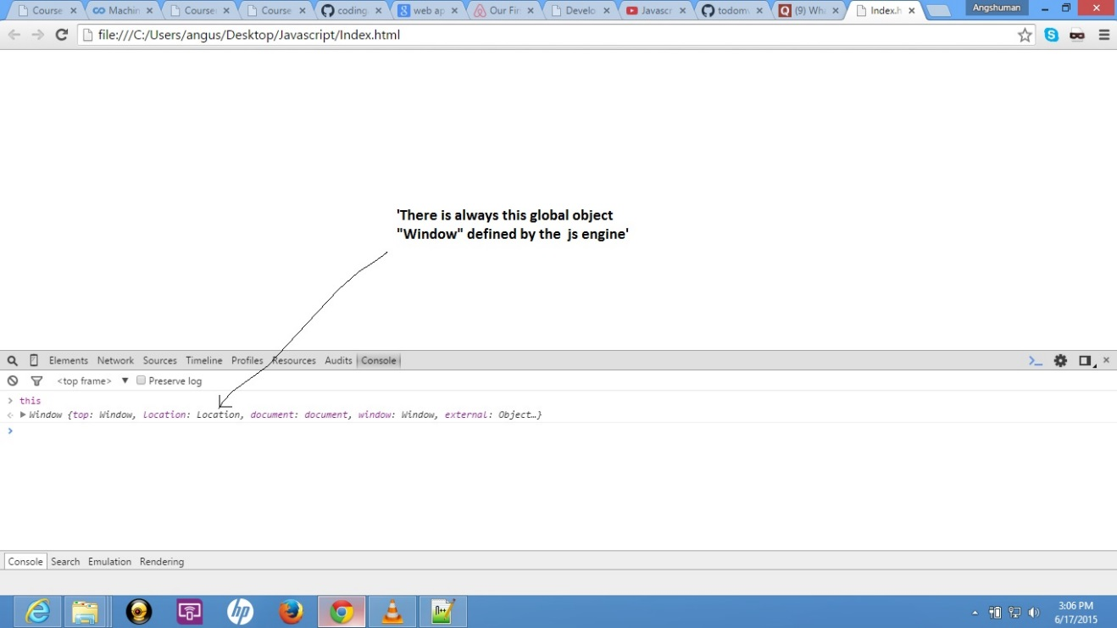

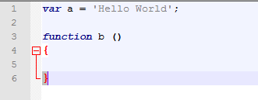

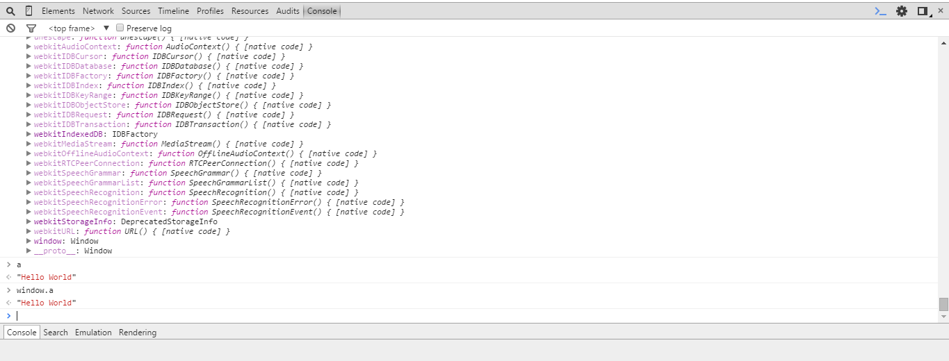

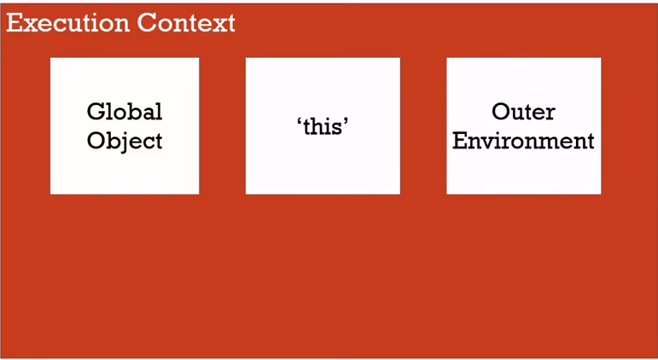

This Execution Context is the wrapper that wraps the code.

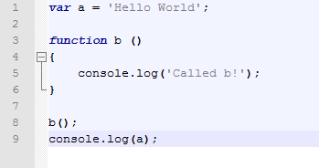

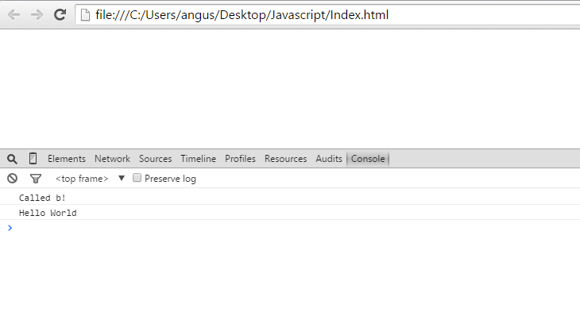

Hoisting: Acts from the top

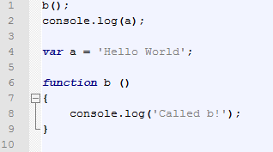

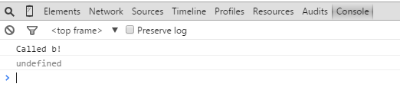

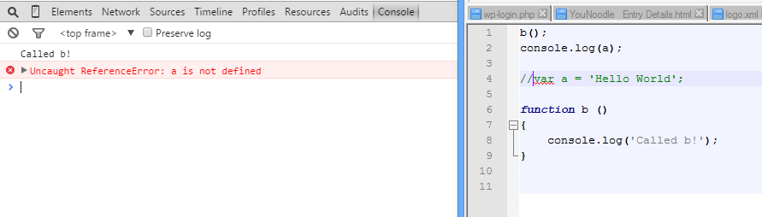

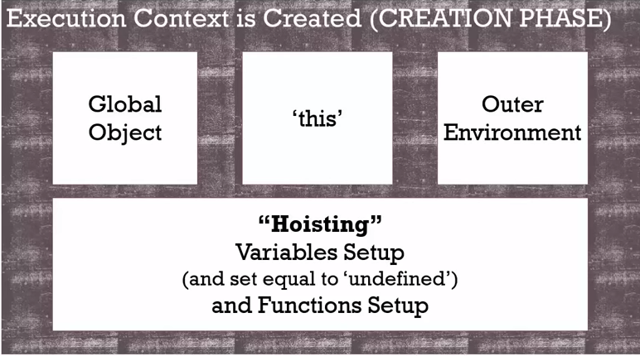

JavaScript makes a placeholder and defines all the variables and functions as ‘undefined’ before its execution.

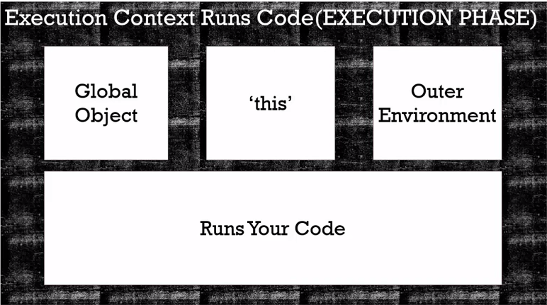

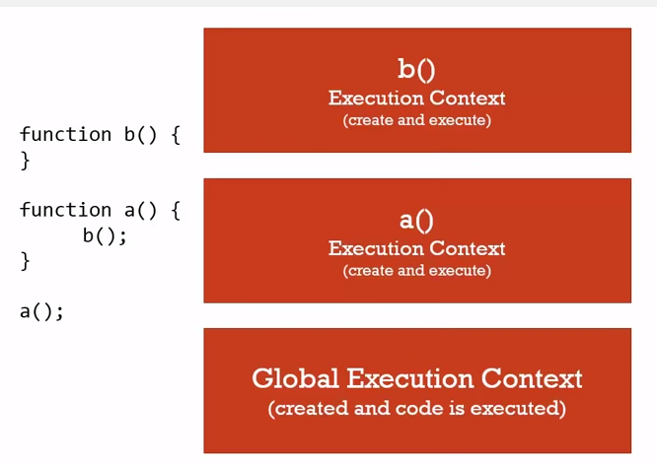

Execution Stack (for function)

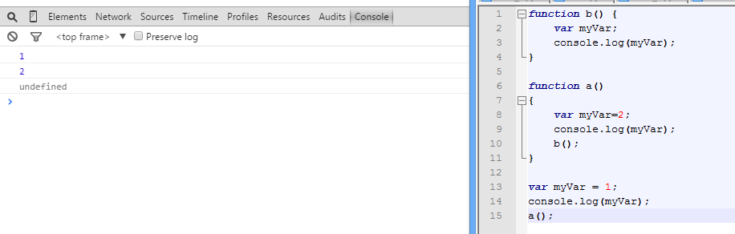

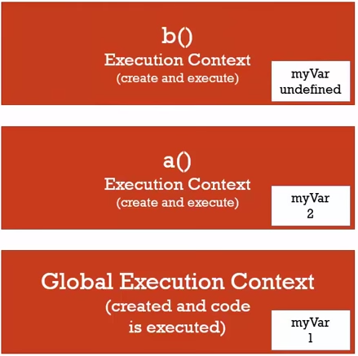

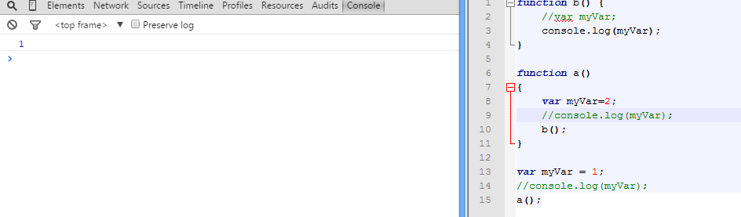

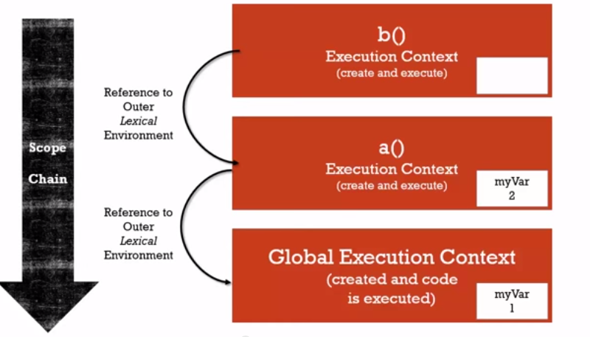

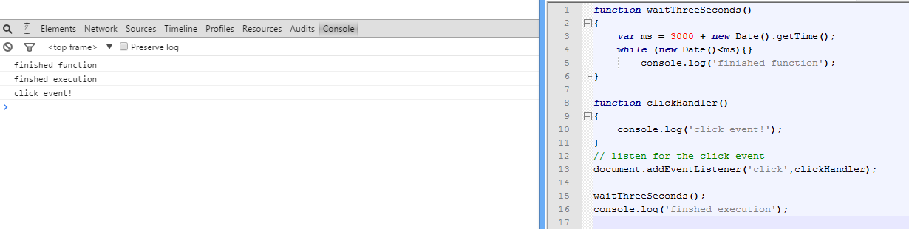

After completing the Execution Stack it looks in the Event Queue.

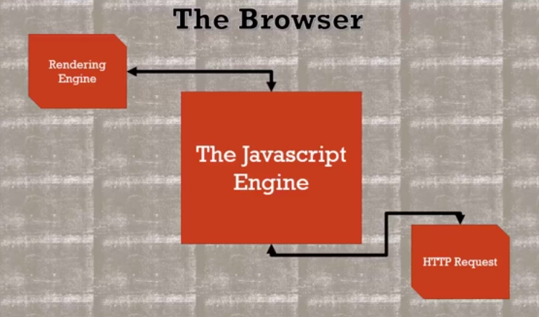

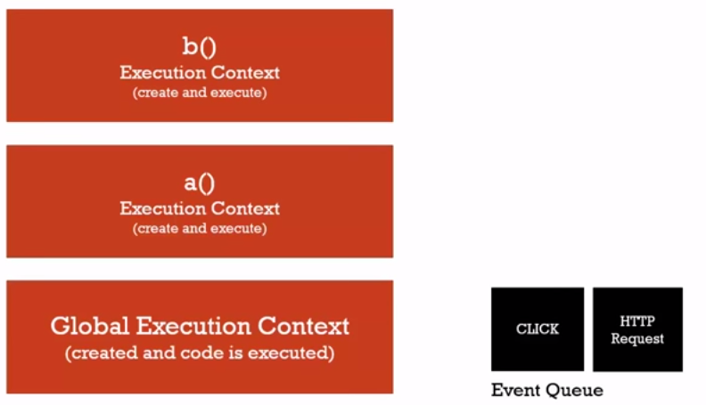

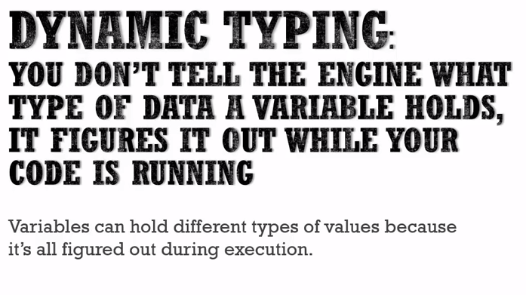

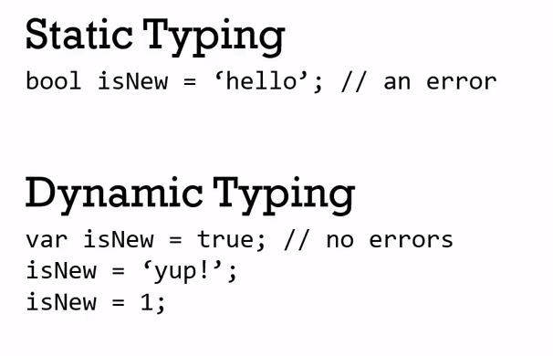

JS

Other Programming Languages

<https://developer.mozilla.org/en-US/docs/Web/JavaScript/Equality_comparisons_and_sameness>

===,==,object.is

| **Sameness Comparisons** | | | | |
| --- | --- | --- | --- | --- |
| **x** | **y** | **==** | **===** | **Object.is** |
| undefined | undefined | true | true | true |
| null | null | true | true | true |
| true | true | true | true | true |
| false | false | true | true | true |
| "foo" | "foo" | true | true | true |
| { foo: "bar" } | x | true | true | true |
| 0 | 0 | true | true | true |
| +0 | -0 | true | true | false |
| 0 | false | true | false | false |
| "" | false | true | false | false |
| "" | 0 | true | false | false |
| "0" | 0 | true | false | false |
| "17" | 17 | true | false | false |
| [1,2] | "1,2" | true | false | false |
| new String("foo") | "foo" | true | false | false |
| null | undefined | true | false | false |
| null | false | false | false | false |
| undefined | false | false | false | false |
| { foo: "bar" } | { foo: "bar" } | false | false | false |
| new String("foo") | new String("foo") | false | false | false |
| 0 | null | false | false | false |
| 0 | NaN | false | false | false |
| "foo" | NaN | false | false | false |
| NaN | NaN | false | false | true |

Objects:

var person = new Object();

person["firstname"]="Angshuman";

person["lastname"]="Gupta"

var firstNameProperty = "firstname";

console.log(person);

console.log(person[firstNameProperty]);

// console.log(person.firstname);

**Output:**

**Objectfirstname: "Angshuman"lastname: "Gupta"__proto__: Object**

**Object.js:8 Angshuman**